
LAPORAN EVALUASI NILAI TENGAH SEMESTER A KELAS TRO-IA TAHUN AKADEMIK 2024/2025
I |  | IP ? 2.0
2 |  | fumlatı l'4flni D s 4 SKS
j |  | Jumloh Nilai fl - u
 |  | M-0 dur ATL ? 2.0

2024/2025  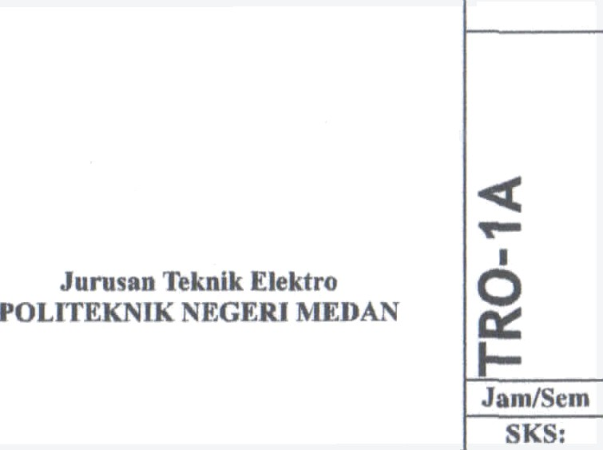  Pragrazo Studt T¥knelogl Rekaycsa Otomaal   |  |  | 1 | 2 | 3 | 4 | S | 6 | 7 | 8 | 9 | 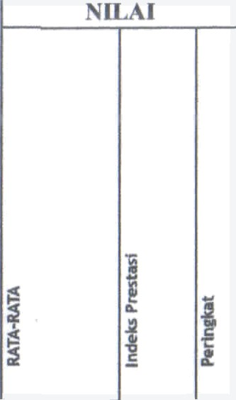 |  | 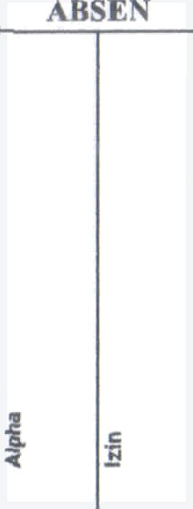 |   sP1:
 |  |  | 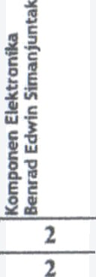 |  |  |  | 
 |  |  |  | 2 | 2 | 2 | 1 | t | 2 | 2 | t
 |  | kal am | mini | elini | suni | nıı»ı | em | mini | su | sen | onu | | x | u | ır i |  | | | ann | | <z | -u | dc
1 | AHDI PERDMTO 8IREGAR | L |2405251003 | 77.00 B+ | 74.00 B | 80.00 A | 60.00 C+ | 7fi.00 B+ | 68.00 C › | 80.00 A | 68.00 C+ |  | 18 | 74.0 i 1 *.28 ] 4 |  | i | 3 i | 0 i 0 | l8 | LB
2 | AHMAD RORD BHAYAJ'JGK ARA DAULAY | L l*<525l0l3 | 75.00 B* | 80.00 A | 71.00 B | 51,00 C |   59.00 C | 77.00 B+ | 90.00 A | 75.00 B+ | 81.00 A | 18 | 73.2 | i 3.28 | 5 |  | | | 3 | | 0 | 0 i 18 | LB
3 | ATRîA TBUI | P | 2405251011 | 70.00 B | 69.00 C+ | 60.00 C+ | 65.00 C+ |  | 74.00 B |  | 72.00 B |  | 18 | 69.1 | C+ | 2.83 | 18 |  |  | 1 | 0 | 0 l | LB
ğ | BARITA RIANTO SIAHAAN | |2405251019 | 73.00 B | 73.00 B | 54.00 C | 60.00 C+ |  | 60.00 C+ | 91.00 A |  | 80.00 A | 18 | 69.3 | C+ l 2.89 | 16 |  | 1 | 1 | 0 ) 0 1 18 | I B
5 | CAKRAWALA D\VîANTARA | 12405251001 | 80.00 A | 69.00 C+ | 58.00 C |  | 60.00 C+ | 61.00 C+ | 80.00 A | 72.00 B | 83.00 A | 18 | 69.2 | C+ | 3.00 | 13 |  | | | 1 | 1 1 18 | LB
6 | CESAR STEVANIUS SINAGA | L |24O5251008 | 73.00 B | 64.00 C+ | 65.00 C+ | 60.00 C8 | 62.00 C+ |  |  |  |  | 18 | 69.8 | B | 2.94 | 14 |  | | | 1 | * 1 1 18 | LB
7 | BF4ATKI BOhA hfANALU | L |240525l0l4 | 70.00 B | 65.00 C+ | 40.00 O | 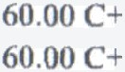  60.00 C+ | 51.00 C | 61.00 C+ | 76.00 Bu | 68.00 C+ | 81.00 A | 18 | 63.6 } C+ | 2.61 | 19 |  | I | i | 0 | 2 { 16 | LB
8 | HAFIZ AGHMAD SHOBRIN SYAKUR | L |240525l012 | 73.00 B |  | 59.00 C |  | 75.00 B-t | 75.00 B+ |  | 71.00 B | 83.00 A | ® I 74.3 | B | 3.28 | 3 |  | 1 | i | * i * i
 |  | L |2405251017 | 80.00 A | 73.00 B | 64.00 C+ |  | 65.00 C+ | 62.00 C-+ | 87.00 A | 70.00 B | 83.00 A | i 71.6 | B | 3.11 | 12 |  | | | i | i 0 1 18 | LB
 |  | P |240525100£ |  | 73.00 B | 75.00 B+ | 65.00 CI | 76.00 B-+ | 76.00 B+ | 90.00 A | 68.00 £{+ | 80.00 A | 18 | 75.3 | B+ | 3.33 | I |  | | | 1 | * 1 ° 1 18 | LB
1IM | sJJABLLEUNARDMMNURUNG | L |240525l009 | 77.00 B+ | 64.00 C+ | 64.00 C+ | 68.00 C* | 63.00 C+ | 75.00 B+ | 84.00 A | 70.00 B | 83.00 A | 18 | 72.0 | B i 1 |  | 1 | 1 | İ i | LB
 |  | L |2405251007 | 83.00 A | 60.00 C+ |  |  | 59.00 C | 76.00 B+ | 92.00 A | 74.00 B | 83.00 A | 18 | 73.9 | B i 3.22 | 7 |  | i | 3 | | 0 0 | 18 | LB
l3 | MUHAMMAD RAFIQ AQIzLAH | L ]240525l0 IS |  | 80.00 A |  | 70.Oo B | 70.00 B | 61.00 C+ | 89.00 A | 70.00 B | 85.00 A | i 73.1 | B 3.22 i |  | i | I | i 0 | 18 | LB
14 | OSVALDO OR£GORIUS TAMBA | 12405251010 | 80.00 A | 70.00 B | 58.00 C | 75.00 B+ | 74.00 B | 70.00 B | 79.00 B+ | 70.00 B |  | 18 | 73.* i i 3.22 i |  | 1 | i | 0 ] 0 | 18 | LB
)5 | PRIMSA HAOANTA | L |2405251002 | 74.00 B | 70.00 B | 59.00 C | 6f.00 C+ | 68.IXI C+ | 68.00 C+ | 77.00 B+ | 70.00 B | 79.00 Bu | i 70.0 | B i *.83 | 17 |  | I | | | o 1 o | le | La
l6 | RACHELAMBLYA PUTR1 | P |240525101£ | 80.00 A | 69.00 C+ | 58.00 C | 68.00 C+ | 78.04 B-+ | 77.00 B+ | 90.00 A | 66.00 C+ | 80.00 A | l 74.0 | B l *.17 | 10 |  | | | 3 { | 0 | 0 | 18 | LB
l7 | RA MADHAN | L |244525l004 | 70.00 B | 89.00 A |  | 73.00 B | 72.00 B | 67.00 C+ | 91.00 A | 70.00 B | 82.00 A | 18 | 7f.2 i + i 3.22 i 6 |  | } | i | 0 0 18 | LB
18 | SAUR MADGASA TUA SIlviAGA | L l**0525l018 |  | 77.00 B+ | 58.00 C | 51.00 C | 68.00 C+ | 62.00 Cm | 89.00 A | 74.00 B | 79.00 Bu | 18 | 70.2 | B | 2.8 i 5 |  | I | i | 0 0 18 | LB
J9 | YEHEZK IEL V. VICTORY TARIGAhi | L |240525l005 |  | 73.00 B |  | 75.00 B+ | 68.fD C+ | 78.00 B+ | 91.00 A |  |  | l 74.8 I ®+ i 3.28 i 2 |  | | | 3 | | 0 | 0 18 | LB
Total i 19 |  |  | 1434 | 1371 | 1162 | 1221 | 1263 | 1314 | 1631 | 1348 | 1549 | 342 i 1365.8 i *8.71 i |  | 0° 00' | 0° 00’ | 57 | | | 2 i 340
Minimum |  |  | 70.00 B | 60.00 C+ | 40.00 D | 51.00 C | 51.00 C |  | 75.00 B+ |  | 79.00 B+ | i 63.6 | C+ | 2.61 |  | 0° 00' | 0° 00’ | i | I i 16
i |  |  | 75 B* | 72 B | 61 C+ | 64 C* | 66 C+ | 69 C+ | 86 A | 71 B | 82 A | i -®® I B i 1 |  | 0° 00' 0° 00’ | 3 | | I i *
Msksûosm l |  |  |  | 89.00 A | 80.00 A | 75.00 B+ | 78.00 B4 | 78.00 B+ | 92.00 A | 75.00 B+ |  | l 75.3 | B+ 3.33 J |  |  | l | | 2 | 18
DISTRTBUSIDAFTARNTLAt:  Kajr : Dr. AM&a AmHia, gT., M.T.  ScE}ut : SquûNo. gT., ALT.  KPS : HI£NBY IJABMJ4 LUC@IAĞf TO&UAN, S.T.,M.T. |  |  |  |  |  |  |  |  |  |  |  |   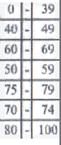  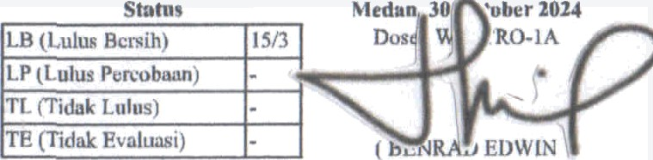    60 - 69 = C*  50 - 59 = C y5 - 7s — B+ 70 - 74 - B | RGu*  = 2.5 z/t LP tLoJus Porcubaan) -  = 2 - * *^! )  - 3.s z/ı TS fTid•k Bv^l•°•i)  - 3 II/t slWAWJUHTafi, S.T.,M.T.)

